Lab 5: FIRST PRINCIPLES MODELING

EEE4514

Marcel 1, 2017

**Gabriel Stroe**

# Filtering

## Overview

The purpose of this lab is to create a system that matches the servo motors physical properties. By using basic physics equations, we should be able to understand exatly how the rotary motor works and create a matching system.

## Theory and Methods

The basis of this lab is that given the physical characteristics of the motor we can rebuild that model in simulation. For this lab we were giving the motors physical specifications and were able to transfer to those values into a control system. The following is the list of values we used to match the motors physical design. The Diagram in question 2 shows the actually use of some these values.

|  |  |
| --- | --- |
| Item | Value |
| Rm | 8.4 ohms |
| Kt=Km | 0.042 |
| Jeq | 2.16E-5 |
| mH | 0.016 Kg |
| JH | 0.98568E-6 |
| JDISC | 16.6E-6 |
| JRotor | 4E-6 |

## Results

As can be seen in the graph bellow, our created curve matches the curve produce by the servo motor very closely. (Servo is in yellow, our function is in pink) Since this system is has more variables then that in LAB 4 and because there are a few values we declared as negligible in the beginning of this lab, it’s not quite as a close fit as te last lab showed. In addition, the last lab had us build a model based on the servo’s actual current output, this one is based on the servo’s theoretical output and does not take into account its current wear and performance.

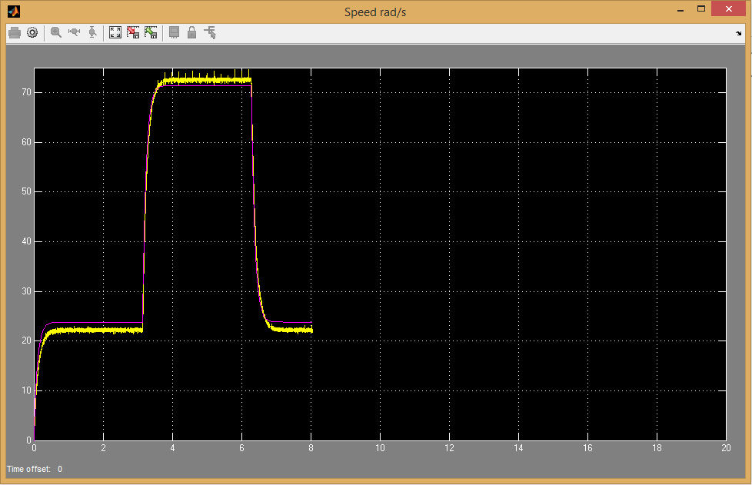

## Questions

1. The design of my servo motor model.  
   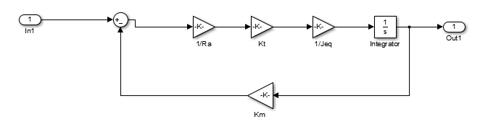
2. Based on the results we had it looks like our design matches the servo motor fairly closely. There are some minor differences due to a few minor differences and factors that are not being considered (as explained in the results section) but otherwise it matches very well.  
   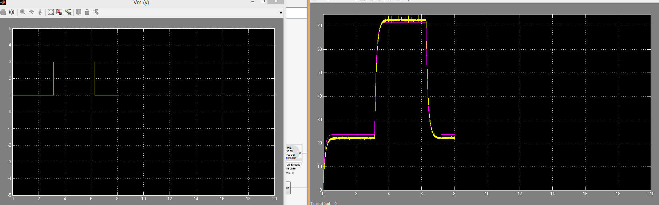

## Conclusions

From this lab we have learned that we can take the theoretical output of any device, such as a servo motor, and build mathematical model that matches the actual output very closely. For this point we should be able to simulate the output of just about any system given the memory and time constraints.